Acceptance tests   
“Acme Rookies v1.0”

|  |  |
| --- | --- |
| Development team | |
| **Identifier** | *G92* |
| **Members** | *Batista Núñez, Francisco.*  *de la Flor Bonilla, Álvaro.*  *Fernández Benjumea, Carmen.*  *Ferrete Molle, José Antonio.*  *Salvat Pérez, Antonio Manuel.*  *Sanchez Hipona, Antonio.* |
| **Testing team** | |
| **Identifier** |  |
| **Members** |  |
| **Indexing data** | |
| **Test designers** | *Salvat Pérez, Antonio Manuel.*  *If you need to contact me:*  *antoniosalvatperez@gmail.com*  *+34 673 53 28 89* |
| **Testers** |  |
| **Notes** | *Use cases of R4.1* |

**Table of contents**

Use case 4.1: Logged as admin, send a rebranding notification 3

# Use case 4.1: Logged as admin, send a rebranding notification

Description

Run a procedure to notify the existing users of the rebranding. The system must guarantee that the process is run only once.

Access

Log in to the system with an existing user of admin (admin/admin).

**Homepage > Header Menu > Login**

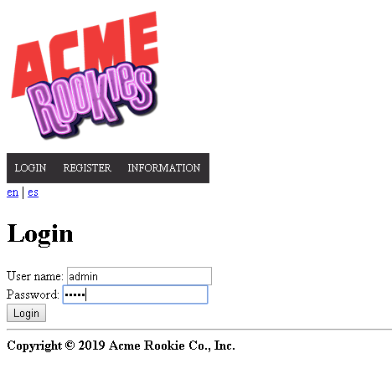

Browse through the available positions. Use the search form.

> Header Menu > Display the "ADMINISTRATOR" options > Configuration

**

And go to the end of the page

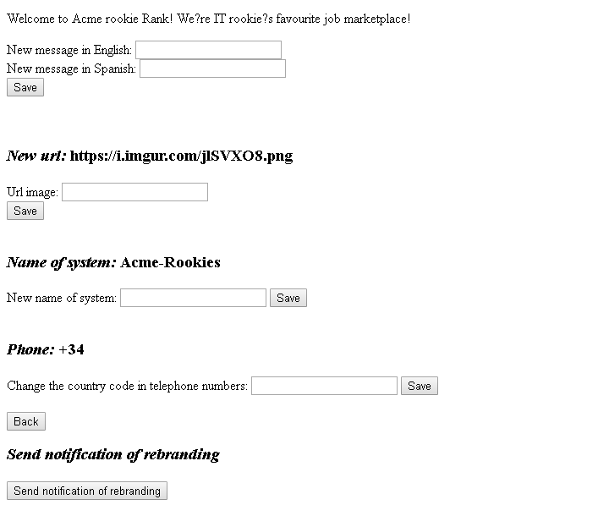

Tests

|  |  |
| --- | --- |
| Test 1 | |
| **Description** | *Send notification of rebranding* |
| **Expected** | *Where we click the button “Send notification of rebranding” the message of a new brand is automatically sended to the actors of the system.* |
| **Outcome** |  |
| **Notes** |  |

|  |  |
| --- | --- |
| Test 2 | |
| **Description** | *See the message* |
| **Expected** | *We will check that the admin have sent the message*  *Go to the list of messages.*      *The message have been sended with the tag “SYSTEM”*    *And all the actors have receive the message*  *For example: with the actor(provider/provider)* |
| **Outcome** |  |
| **Notes** |  |

|  |  |
| --- | --- |
| Test 3 | |
| **Description** | *Send again* |
| **Expected** | *When you try to send the notification again with the same admin or with other, the application won´t do anything.*      *The system don´t send the message* |
| **Outcome** |  |
| **Notes** |  |